भारतमौसमविज्ञानविभाग |  | India Meteorological Department
Monday,16th June 2025 (26 Jyeshtha 1947 Saka)
Summary of observations recorded at 0830 hours IST: Southwest monsoon has further advanced into remaining parts of central Arabian Sea; some parts of north Arabian Sea and Gujarat; remaining parts of Konkan, Madhya Maharashtra and Telangana; some parts of Madhya Pradesh; some more parts of Vidarbha, Chhattisgarh, and Odisha. The Northern Limit of Monsoon passes through 20.0°N/60°E, 20.5°N/65°E, Veraval, Bhavnagar, Vadodara, Khargone, Amravati, Durg, Bargarh, Chandbali, Sandhead Island, 23.5°N/89.5°E, Balurghat and 30°N/85°E. Conditions are favourable for further advance of Southwest monsoon over remaining parts of North Arabian Sea; some more parts of Gujarat & Madhya Pradesh; remaining parts of Vidarbha, Chhattisgarh & Odisha; some parts of Gangetic West Bengal, Jharkhand; remaining parts of Northwest Bay of Bengal, Sub-Himalayan West Bengal; some parts of Bihar and East Uttar Pradesh during next 2-3 days.. The cyclonic circulation over northwest Bay of Bengal & neighbourhood persisted and seen between 1.5 & 5.8 km above m. s. l. tilting southwestwards with height. The upper air cyclonic circulation over north Rajasthan lay over south Punjab & neighbourhood at 0.9 km above m. s. l. The upper air cyclonic circulation over south Himachal Pradesh & adjoining north Uttarakhand lay over northeast Punjab & neighbourhood at 3.1 km above m. s. l. The Western Disturbance as a trough in middle tropospheric westerlies with its axis at 5.8 km above m. s. l. ran roughly along Long. 70°E to the north of Lat. 26°N. persisted. An upper air cyclonic circulation lay over northeast Assam & neighbourhood and extended upto 1.5 km above m. s. l. The upper air cyclonic circulation over south Madhya Maharashtra & neighbourhood lay over central parts of Konkan and adjoining eastcentral Arabian sea of yesterday evening. It then lay over south Gujarat & neighbourhood and extended upto 7.6 km above m. s. l. Under its influence, a Low-Pressure area is likely to form over the same region during next 24 hours and it is likely to become more marked and move north-northwestwards during subsequent 24 hours. The trough from east Madhya Pradesh to Bangladesh across Chhattisgarh, Jharkhand & Gangetic West Bengal and extended upto 1.5 km above m. s. l. tilting southwestwards with height became less marked. The cyclonic circulation over central Assam & neighbourhood became less marked. The trough from the upper air cyclonic circulation over north Rajasthan & neighbourhood to west Madhya Pradesh became less marked. The upper air cyclonic circulation over east Uttar Pradesh & neighbourhood became less marked.
Day temperatures were markedly above normal (> 5.1°C) at most places over Arunachal Pradesh; at isolated places over Assam & Meghalaya, east Uttar Pradesh and Himachal Pradesh. appreciably above normal (3.1°C to 5.0°C) at few places over Sub Himalayan West Bengal & Sikkim; at isolated places over Odisha, Jammu-Kashmir-Ladakh-Gilgit-Baltistan-Muzaffarabad, east Madhya Pradesh, Vidarbha and Chhattisgarh. above normal (1.6°C to 3.0°C) at many places over Jharkhand; at few places over Bihar; at isolated places over Nagaland, Manipur, Mizoram & Tripura, Punjab, west Madhya Pradesh, Gujarat Region, Saurashtra & Kutch, Telangana and Tamil Nadu, Puducherry & Karaikal. near normal (-1.5°C to 1.5°C) at many places over west Uttar Pradesh, west Rajasthan, east Rajasthan, Konkan & Goa, Madhya Maharashtra, Marathwada and coastal Andhra Pradesh & Yanam; at most places over Andaman & Nicobar Islands and Gangetic West Bengal; at few places over Haryana-Chandigarh-Delhi and Lakshadweep; at isolated places over Uttarakhand, Rayalaseema, south interior Karnataka and Kerala & Mahe. The highest maximum temperature of 43.2°C was reported at Varanasi (Uttar Pradesh).
The Southwest Monsoon has been active over Konkan & Goa, coastal Karnataka and Kerala. It has been subdued over Telangana.
Total 329 stations reported rainfall today. Total rainfall is 446.7 cm. Total 317 stations reported rainfall today whose normals are available. Total rainfall is 409.2 cm with normal station total is 241.9 cm.
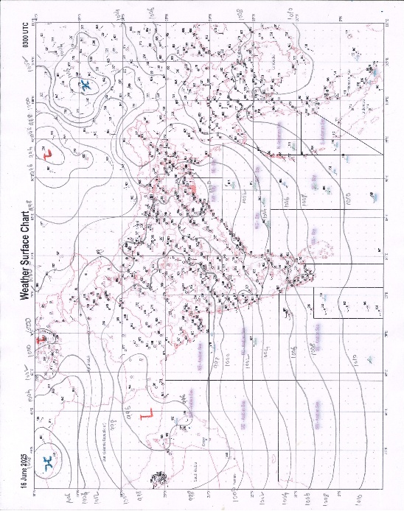 | 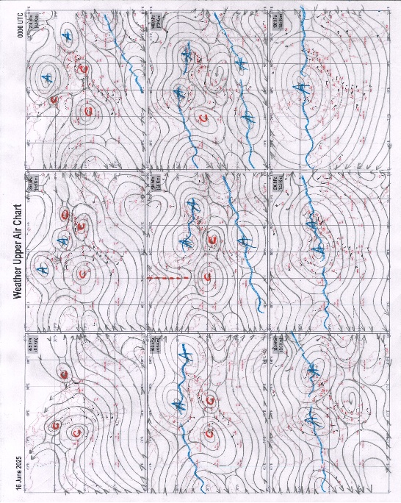
g.1. Analysed surface chart based on 03z observation | Fig.2. Analysed upper air chart based on 00z observation

Dr. S.D.Sanap
Scientist ‘D’
CR & S Office, Pune  Issued at 1245 hrs. IST |  | Weather Forecasting Division  CR&S, Pune

Indian regions | Realised rainfall (chief amount in cm during past 24 hrs):
East | many places: Assam & Meghalaya+, Nagaland-Manipur-Mizoram-Tripura, Sub-Himalayan West Bengal & Sikkim+++ and Odisha+++  a few places: Arunachal Pradesh+  isolated places: Gangetic West Bengal, Jharkhand and Bihar  Banki 16.5, Bhatkawa tea estate 12.0, Ranpur 11.6, Hazo ARG 10.8, Naharlagun 9.8, Tangla ARG 9.7, Leesh river tea garden 8.5, Chottabekra 6.4, Cherrapunji 6.1, Bano simdega kvk AWS 6.0, Mangkolemba 5.7, Anini AWS 5.5, Hasimara 4.4, Lengpui 3.8, Basirhat (pt) 3.6, Andar 3.5, Keonjhargarh & Sadar chaibasa 3.4 each, Mo saltlake 3.3, Bikramganj 3.0, Dehri 1.0, Chaibasa 0.9, Dum dum 0.8, Pasighat AP 0.2.
North | many places: Uttarakhand+  a few places: west Uttar Pradesh+++, Himachal Pradesh, west Rajasthan and east Rajasthan+  isolated places: east Uttar Pradesh+, Haryana, Punjab and Jammu-Kashmir and Ladakh  Bareilly CWC 14.9, Bareilly PBO 14.7, Nakur 12.0, Amet 9.6, Kumbhalgarh SR 8.4, Mankapur 8.3, Shardanagar 6.6, Dehra dun 6.5, Tajewala 6.2, Tehri (CWC) 5.6, Gorakhpur 5.5, Deoprayag 5.2, Jammu AWS & Bilara 4.9 each, Jammu & Kota-aero 4.6 each, Sinderi SR 4.0, Kangra AP 3.4, Khanpur REV 3.2, Rajouri ARG 2.9, Karsog 2.7, Jodhpur tehsil SR 1.8, Dharmsala 1.6, Narnaul 1.5, Nabha ARG 1.1, Malikpur 1.0, Patiala 0.2.
Central | a few places: west Madhya Pradesh+, east Madhya Pradesh and Chhattisgarh  isolated places: Vidarbha  Lateri 6.8, Durg 5.7, Sihora 5.6, Pandhurna 5.4, Gidam 5.1, Kawardha 4.3, Khandwa 4.1, Warud 4.0, Prabhat pattan 3.7, Satna (raghurajnagar) 3.3, Goregaon 2.7, Gondia 1.6.
Peninsula | most places: Konkan & Goa+++, coastal Karnataka# and Kerala#  many places: Madhya Maharashtra# and south interior Karnataka+++  a few places: Gujarat Region+++, Saurashtra & Kutch+ and north interior Karnataka+  isolated places: Marathwada, coastal Andhra Pradesh, Telangana, Rayalaseema and Tamil Nadu#  Avalanche 29.2, Manki 26.9, Siddapura 25.2, Mangaluru AP 22.6, Gaganbawada & Thennala AWS 21.5 each, Agumbe emo 20.2, Kottigehara 20.0, Pawarwadi ARG 18.2, Vadakara 17.8, Chinnakalar 17.6, Radhanagari 17.2, Mahabaleshwar 15.8, Awalegaon ARG 15.7, Dabhoi 15.3, Kannur 14.0, Sankheda 13.0, Bhagamandala 12.2, Valparai PTO 11.5, Colaba 10.0, Shihor 9.9, Kittur 6.8, Khanapur 6.6, Khambha 6.5, V.vidyanagar SR 6.2, Belagavi PTO 5.3, Mahuva (b) & Vaijapur 3.8 each, Dornipadu 2.5, Bayyaram 2.4, Nellore 2.3, Seethanagaram 2.0, Maheswaram 1.9, Parvathipuram & Rudravaram 1.4 each, Gangapur 1.2, Cuddapah 0.8, Sambhajinagarobsy 0.4, Mahbubnagar 0.2.
Islands | most places: Lakshadweep  a few places: Andaman & Nicobar  Minicoy 5.2, Maya bandar 3.7, Agathi 2.2, Long island 1.7, Amini 1.6, Hut bay 0.5.
Table 2. Forecast / warnings (distribution of rain / thundershowers) for 7 days (valid from time of origin upto 0830 hrs IST of next day)
Sr. No |  | Sub-division Name | Day 1 | Day 2 | Day 3 | Day 4 | Day 5 | Day 6 | Day 7 | Sr. No. | Sub-division Name | Day 1 | Day 2 | Day 3 | Day 4 | Day 5 | Day 6 | Day 7
 |  |  | 16 Jun | 17 Jun | 18 Jun | 19 Jun | 20 Jun | 21 Jun | 22 Jun |  |  | 16 Jun | 17 Jun | 18 Jun | 19 Jun | 20 Jun | 21 Jun | 22 Jun
 | 1 | Andaman Nicobar Islands | F  | F  | F  | W | W | W | F | 19 | west Madhya Pradesh | S  | S  | S  | F +  | F +  | W | W + 
 | 2 | Arunachal Pradesh | F +  | W ++ | W++ | W ++ | W++ | F + | F ++  | 20 | east Madhya Pradesh | F  | F +  | W  | W ++  | W ++  | W | W ++ 
 | 3 | Assam-Meghalaya | W ++  | W +  | W++ | W++ | W++  | F + | F ++  | 21 | Gujarat region | W #  | W ++  | F +  | F +  | F +  | F + | F +
 | 4 | Nagaland-Manipur-Mizoram-Tripura | W ++  | W ++  | W ++  | W ++  | W ++  | W + | W ++  | 22 | Saurashtra and Kutch | W #  | W #  | W ++  | F +  | S +  | S + | S +
 | 5 | Sub Himalayan West Bengal/Sikkim | W+ | F +  | F +  | W ++ | W + | W | W + | 23 | Konkan and Goa | W #  | W++ | W++ | W++ | W + | W + | W +
 | 6 | Gangetic West Bengal | F+ | W++ | W++ | W + | F | F | F | 24 | Madhya Maharashtra | S #  | S ++ | I ++ | I ++ | I + | I + | I +
 | 7 | Odisha | W++ | W++ | W++ | F +  | S + | S | S + | 25 | Marathwada | I  | I | I | I  | I  | I | I 
 | 8 | Jharkhand | F + | W + | W++ | W++ | W+ | F | F+  | 26 | Vidarbha | S +  | S+ | S  | F  | F  | F | S
 | 9 | Bihar | I + | S + | S++ | F++ | F+ | F + | S + | 27 | Chhattisgarh | I +  | F++ | F++ | F+ | F+ | S | S+
 | 10 | east Uttar Pradesh | S + | S + | F+ | W++ | W++ | F++ | F++ | 28 | Coastal Andhra Pradesh and Yanam | S  | I  | I  | I  | I  | I | I 
 | 11 | west Uttar Pradesh | F + | S  | S | F + | W+ | F+ | F + | 29 | Telangana | S  | I  | I  | I  | I  | I | I 
 | 12 | Uttarakhand | W + | W + | W+ | W + | W+ | W+ | W + | 30 | Rayalaseema | S | I  | I  | I  | I  | I | I 
 | 13 | Haryana,Chandigarh and Delhi | S + | S  | S  | S  | F  | W+ | W  | 31 | Tamil Nadu, Puducherry and Karaikal | S ++ | S + | I +  | I | I | I | I
 | 14 | Punjab | S + | S  | I  | I  | S  | S | F  | 32 | Coastal Karnataka | W # | W++ | W+ | W | W | W | W
 | 15 | Himachal Pradesh | F  | F  | S  | S  | S  | F+ | F  | 33 | North interior Karnataka | F ++ | S + | S+ | I | I | I | I
 | 16 | Jammu-Kashmir and Ladakh | S  | I  | I  | I  | I  | S+ | S  | 34 | South interior Karnataka | F #  | F++ | S + | I | I | I | I
 | 17 | west Rajasthan | F+ | I  | I  | I  | I  | I  | I  | 35 | Kerala and Mahe | W++ | W+ | W +  | F | F | F | F
 | 18 | east Rajasthan | S + | I  | I  | I  | I + | S+ | S + | 36 | Lakshadweep | W  | W | W  | F | F | F | F
Legends: D = Dry I = Isolated S = Scattered F = Fairly widespread W = Widespread #= heavy to very heavy rain at a few places with extremely heavy rain at isolated places +++= heavy rain at a few places with very heavy rain at Isolated places ++= heavy to very heavy rainfall @=Isolated exceptionally heavy rainfall + = heavy rain ●/*= rain or snow ♦ = very light rain ≡=fog= thunderstorm with lightning =Squall / Gusty / gale / strong wind ­ =cold wave/cold day += heat wave/warm night/hot and humid weathe r=Duststorm =ground frost = Hail

Fig. 4: Districtwise warnings for five days for Maharashtra State
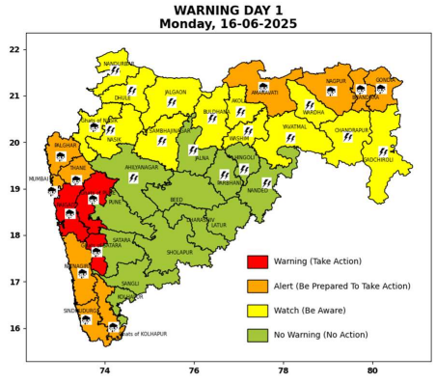 | 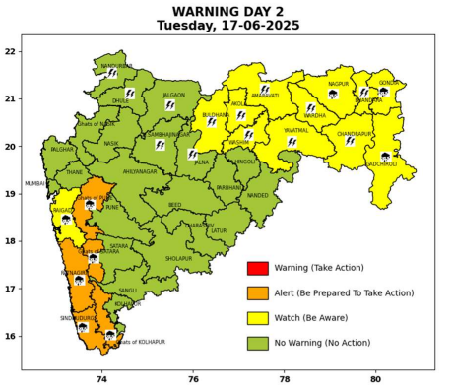 | 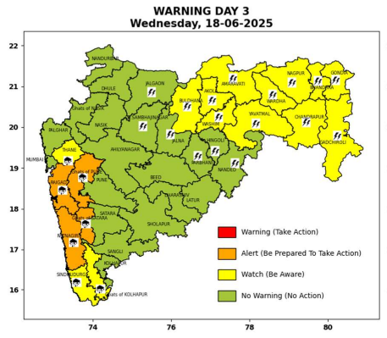 | 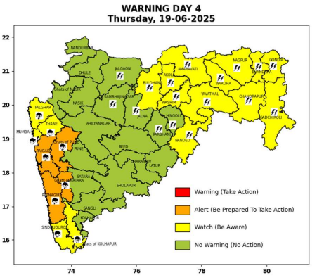 | 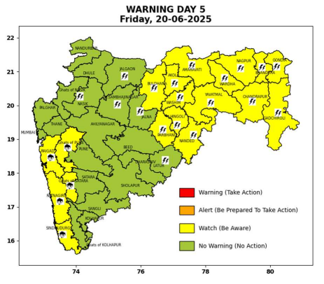

Pune, Lohegaon and Pashan observations at 0830 hrs. IST of Today
 | Temperature (°C) |  |  |  |  | Humidity (%) |  |  |  | Rainfall (mm)
 | Max.  past  24 hrs | Dep.  from  normal | Min.  past  24 hrs. | Dep.  from  normal | Dry  Bulb | At 0830 hrs. IST | Dep.  From  normal | At 1730  hrs. IST of y’day | Dep.  from  normal | Past  24 hrs. | Since  1st June | Dep.  from  normal
PNE | 29.4 | -1.5 | 22.6 | -0.3 | 23.4 | 95 | 16 | 88 | 18 | 30.6 | 163.5 | 77.6
PSN | 28.4 | - | 21.5 | - | 23.2 | 98 | - | 95 | - | 42.5 | 180.2 | -
LHG | 31.0 | -1.0 | 24.7 | 3.7 | 24.9 | 89 | 13 | 72 | 10 | 22.4 | 161.2 | 107.0

 |  |  |  |  |  |  | Local (Pune and neighbourhood) forecast
Max./Min. Temperature (°C) |  |  |  |  |  |  |  |  | Weather
Date | Pune | Pashan | Lohegaon | Chinchwad | Lavale | Magarpatta | NDA | Koregoan Park
16/06/25 | 26/22.6* | 25/21.5* | 28/24.7* | 25/23.3* | 23/22.4* | 28/23.8* | 25/22.4* | 27/23.9* | Generally cloudy sky. Light to moderate rain very likely.
17/06/25 | 29/21 | 28/21 | 31/25 | 29/22 | 28/21 | 31/23 | 29/21 | 30/22 | Generally cloudy sky. Light to moderate rain very likely.
18/06/25 | 30/22 | 29/22 | 32/25 | 30/23 | 29/22 | 32/24 | 30/22 | 31/23 | Generally cloudy sky. Light rain very likely.
19/06/25 | 30/23 | 29/23 | 32/26 | 30/24 | 29/23 | 32/25 | 30/23 | 31/24 | Generally cloudy sky. Light rain very likely.
20/06/25 | 30/23 | 29/23 | 32/26 | 30/24 | 29/23 | 32/25 | 30/23 | 31/24 | Generally cloudy sky. Light rain very likely.
21/06/25 | 30/23 | 29/23 | 32/26 | 30/24 | 29/23 | 32/25 | 30/23 | 31/24 | Generally cloudy sky. Light rain very likely.
22/06/25 | 31/22 | 30/22 | 33/27 | 31/23 | 30/22 | 33/24 | 31/22 | 32/23 | Generally cloudy sky. Light rain very likely.
Rainfall Distribution |  |  | Rainfall Categories | Rainfall (mm) |  | Cloud condition |  |  |  | Rainfall Intensity |  | Range
Widespread (W) | 76-100% |  | Very Light rain | Trace to 2.4 mm |  | Mainly clear sky |  | 1-2 oktas |  | Light Spell |  | 1 cm/hr
 |  |  | Light rain | 2.5 to 15.5 mm |  | Partly cloudy sky |  | 3-4 oktas |  | Moderate Spell |  | 1-2 cm/hr
Fairly Widespread (FW) | 51 – 75% |  | Moderate rain | 15.6 to 64.4 mm |  | Generally cloudy sky |  | 5-7 oktas |  | Intense Spell |  | 2-3 cm/hr
Scattered (S) | 26 – 50% |  | Heavy rain | 64.5 to 115.5 mm |  | Overcast |  | 8 oktas |  | Very Intense Spell |  | 3-5 cm/hr
isolated (I) | 1 – 25% |  | Very heavy rain | 115.6 to 204.4 mm |  |  |  |  |  | Extremely Intense Spell |  | 5-10 cm/hr
D (D) | No Rain |  | Extremely heavy rain | ≥ 204.5 mm |  |  |  |  |  | Cloudburst |  | > 10 cm/hr
Probability Terms in %: |  |  | Heavy snow | 6.5 to 11.5 cms water equivalent of rain
unlikely | < 25 |  | Very heavy snow | 11.6 to 20.4 cms water equivalent of rain
likely | between 25 50
very likely | between 51 75
most likely | >75
* = realized temperature
Mumbai (Colaba) |  |  |  | Nagpur (AP)
Date 2025 | T max °C | T min °C | Weather | T max °C | T min °C | Weather
16/06 | 29 | 25 | Generally cloudy sky with Heavy to very heavy rainfall. | 38 | 28 | Heavy rainfall or thundershowers accompanied with lightning & gusty winds(40-50kmph).
17/06 | 30 | 26 | Generally cloudy sky with intermittent rain. | 38 | 27 | Heavy rain or thundershowers accompanied with lightning
18/06 | 31 | 26 | Generally cloudy sky with intermittent rain. | 37 | 26 | Heavy rain or thundershowers accompanied with lightning
19/06 | 32 | 25 | Generally cloudy sky with Heavy rainfall. | 37 | 26 | Heavy rain or thundershowers accompanied with lightning
20/06 | 32 | 25 | Generally cloudy sky with moderate rain. | 36 | 25 | Partly cloudy sky with possibility of development of thunder lightning.
21/06 | 31 | 24 | Rain. | 36 | 25 | Partly cloudy sky with possibility of development of thunder lightning.
22/06 | 31 | 24 | Rain. | 36 | 25 | Partly cloudy sky with possibility of development of thunder lightning.

